CSCI251 A2 summary
Interpretation of requirements
- Area must be manually computed and stored by the user (default 0)

- Assume I can add additional attributes and functions to the Base class (ShapeTwoD)

- Main driver is Assn2.cpp with util.cpp holding all functions implementations

- Assume can use vectors (STL library)

Program Summary
Assn2.cpp
- Display main menu

Program Flow:
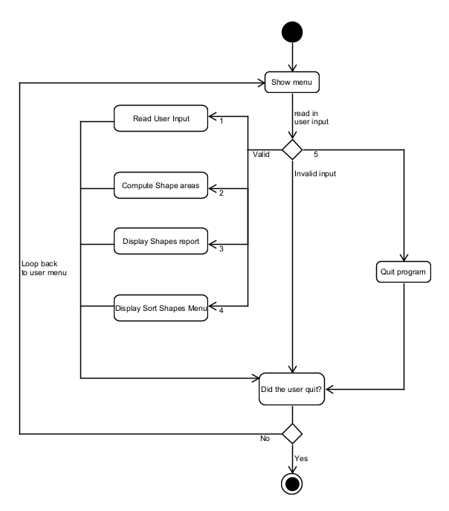

Square / Rectangle
.h file
- Store the minimum / maximum X and Y as attributes
- Declare vectors to store points on perimeter and points on Shape

.cpp file
IsPointInShape()
- If X and Y satisfies both the conditions:
- X is within the minimum and maximum X
- Y is within the minimum and maximum Y

IsPointOnShape()
- Check if Y value lies on Min or Max Y
- Y value equals Min or Max Y
- X lies within Min X and Max X

- Check if X value lies on Min or Max X
- X value equals Min or Max X
- Y lies within Min Y and Max Y

Circle
.h file
- Store the center point and radius as attributes
- Declare vectors to store points on perimeter and points on Shape

.cpp file
IsPointInShape()
- Use Pythagoras theorem to find the shortest distance from the point to the circle center
- If distance is less than radius, the point lies within the circle

IsPointOnShape()
- Use Pythagoras theorem to find the shortest distance from the point to the circle center
- If distance equals radius, the point lies on the circle

Cross
.h file
- Store the minimum and maximum X and Y as attributes
- Store the bounds (X and Y) of the 4 corner squares
- Declare vectors to store points on perimeter and points on Shape

.cpp file
computeArea()
- Find the area of the square and subtract the area of the 4 corner squares

IsPointInShape()
- Check if the points X and Y lie inside the Square
- If yes, check If it lies in any of the 4 corner squares.
- If no, the point lies within the cross

IsPointOnShape()
- Check if the values lie on the minimum / maximum X and Y values
- For vertical lines:
  - If X equals the line’s X value AND Y value lies within Y range bounds
- For horizontal lines:
  - If Y equals the line’s Y value AND X value lies within the X range bounds

- Check for each of the 4 corner squares if the X and Y values lie on either of the 2 lines

util.cpp
readInput() function
- Request user input for shape name, type and vertices
- Provide option for user to continue adding shapes

Program Flow:
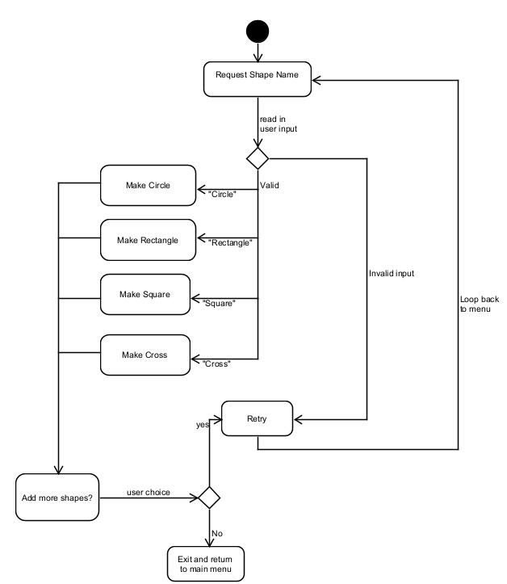

sortShapesMenu() function
- Display the menu of shape sorting options
- Return to main menu if user enter ‘q’

Program Flow:
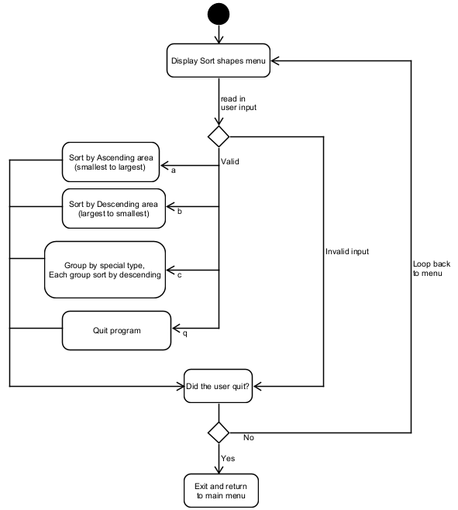

sortAsc() / sortDesc function
- Sort shapes by area using Bubble sort implementation (reduce and conquer)

Program description:
- Check if sorting array partially or whole array
- If partial, use the startPos and endPos argument

- Outer loop over size of array to be sorted - 1
- N – 1: Number of passes to be made
- After second last sort, the first element would already be sorted

- Inner loop over the index of the array portion to be sorted
- Check current Position’s area with next Position’s area
- Swap if not in order
(depending on ascending or descending)
- Since last element is now sorted, decrement the last Index position (next pass will be 1 less than the current)

groupSpecialType() function
- Arrange elements in the array such that special type “WS” is in front
- Return index position of the last “WS” Shape in the array

Program description:
- Keep track of the last “WS” type element
- Set as -1 first

- Loop over the array and check if the current shape is “WS” type

- If no, continue

- If yes, increment the position from the last “WS” type and swap with current shape

